**Application Development**

**Stack Overflow (Clone App)**

**APP-TECHNOLOGY**

**Frontend:**

* **React.js with redux.**
* **Styling: SASS And Bootstrap**

**Backend:**

* **Node.js & Express.js Framework**
* **Database: MySQL**
* **API-Test: insomnia**

1. **First Create account in website sign up and sign in.**

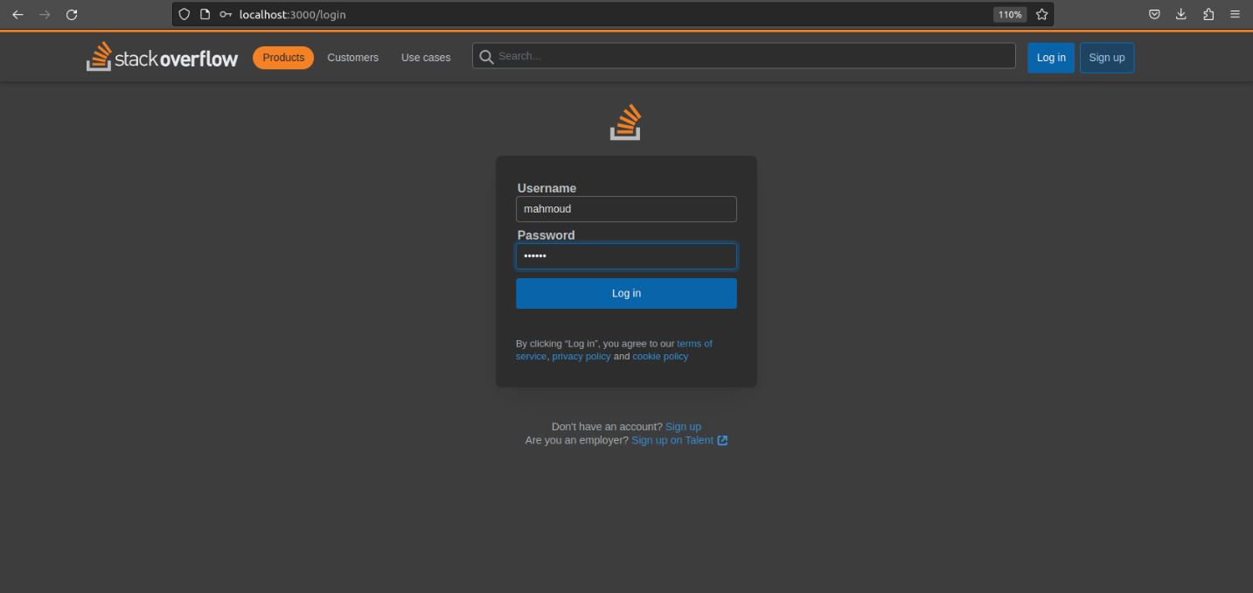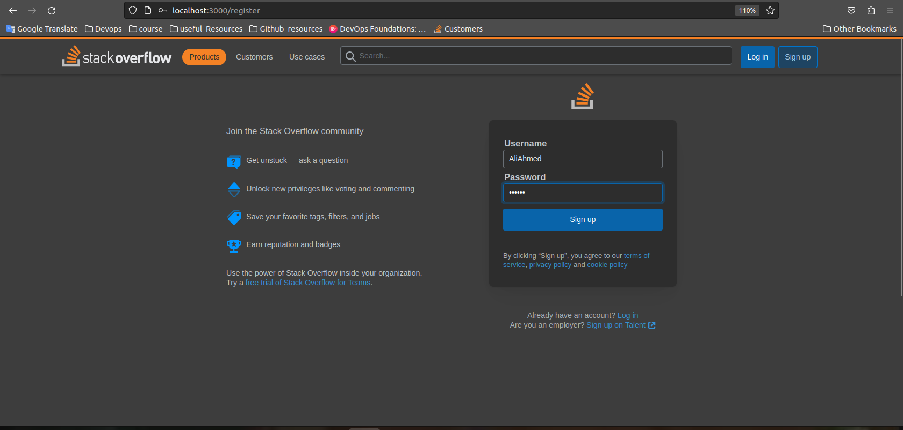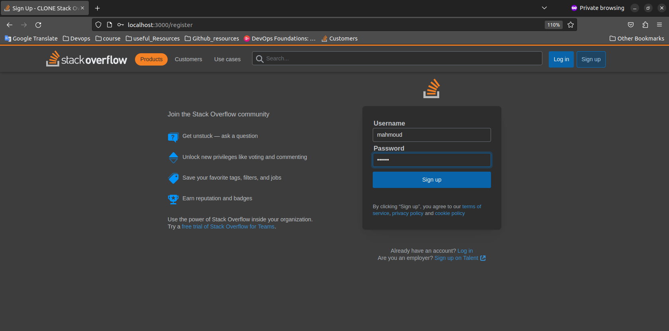

1. **Show posts in website.**

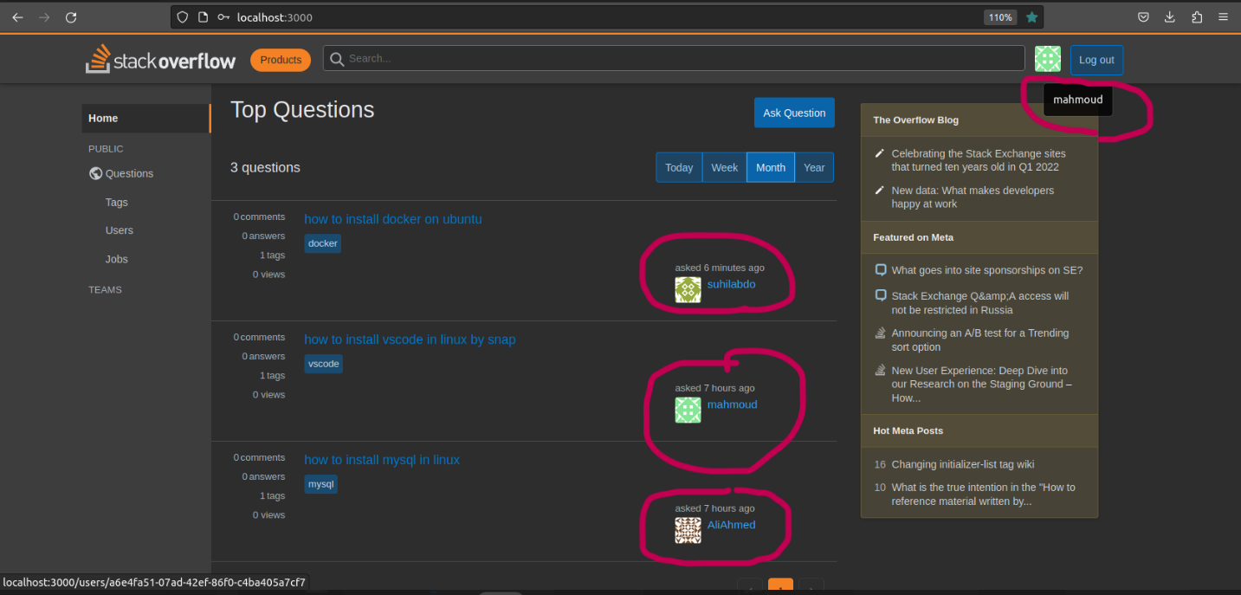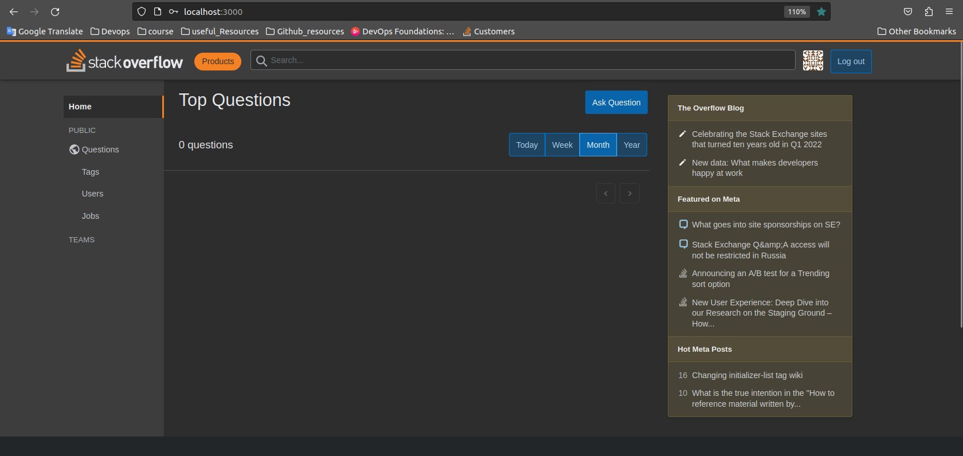

1. **Create posts.**

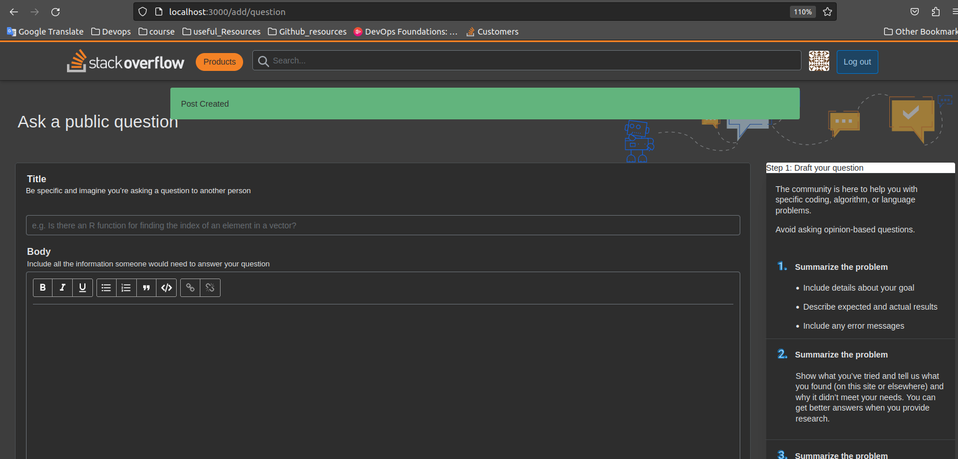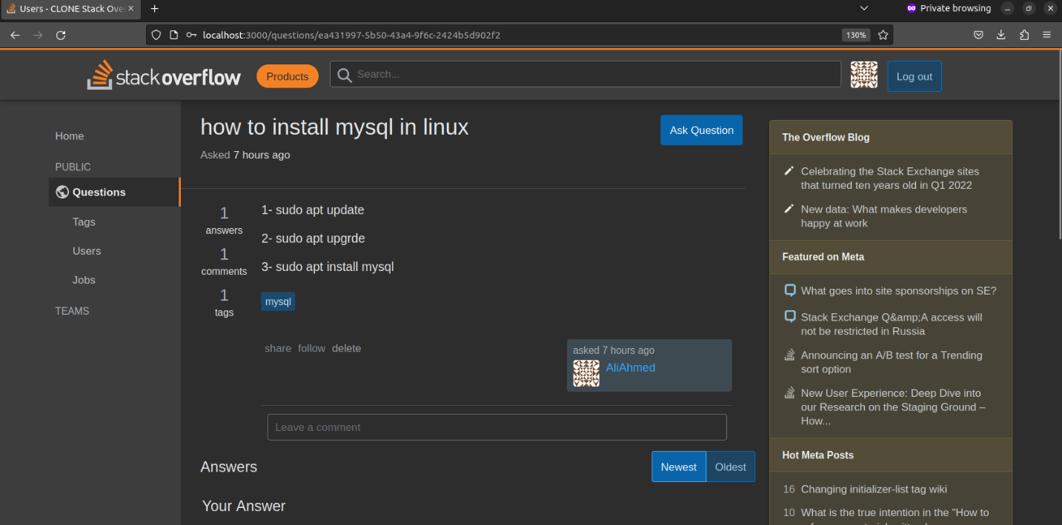

1. **Show the oldest post and newest.**

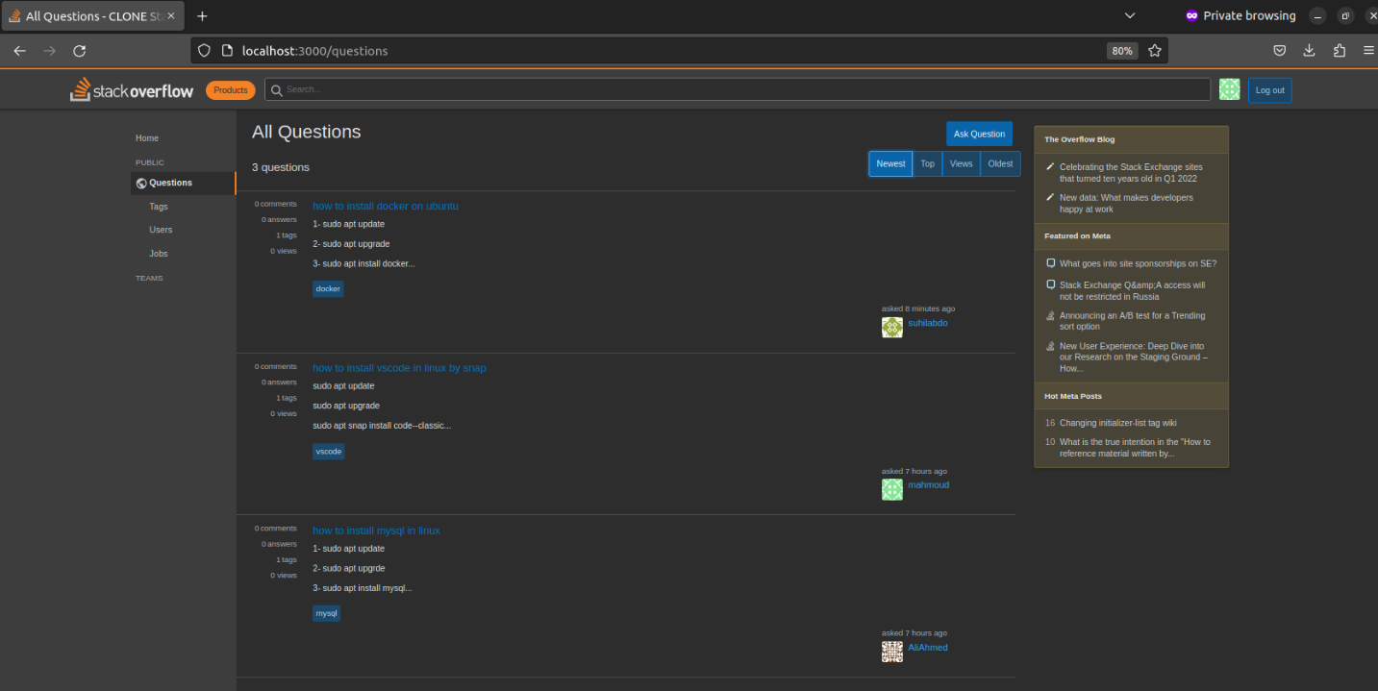

1. **Leave comment.**

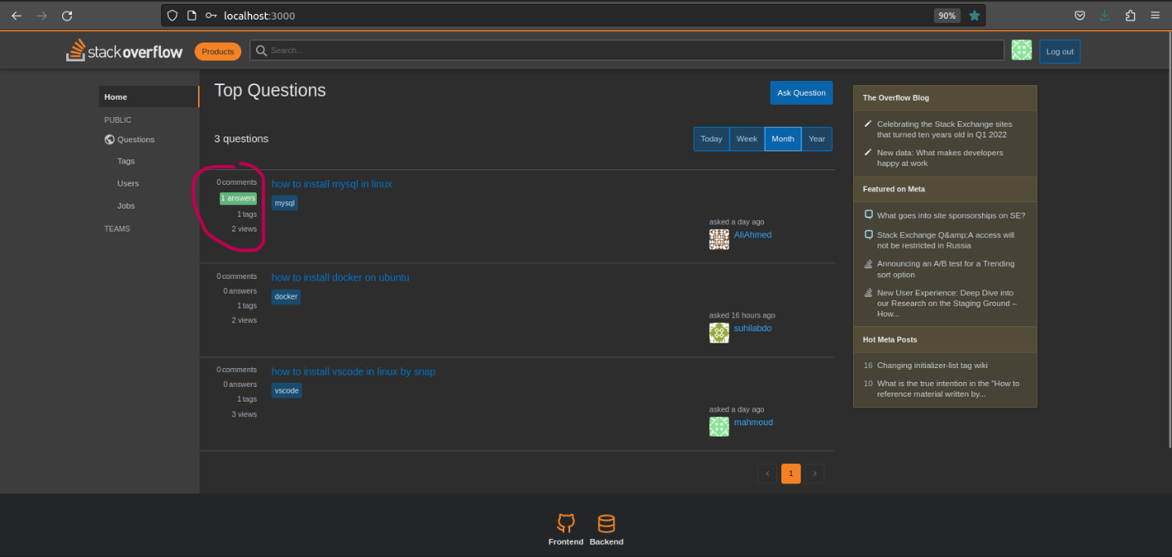

1. Find the post.

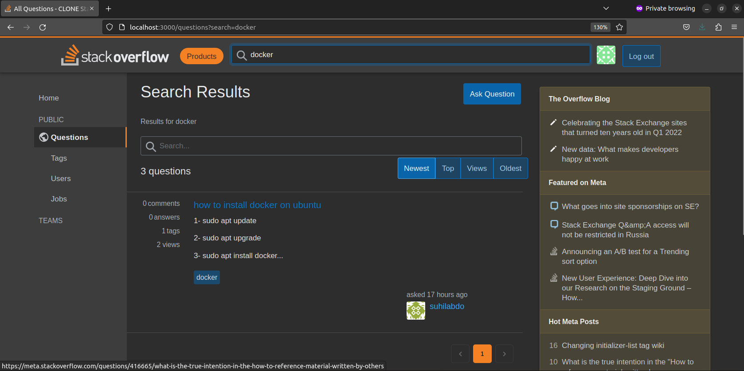

1. Show database.

